2024 IGU Urban Commission Annual Conference
‘(Re-)Thinking cities and the urban: from the global to the local‘

Cork, Ireland – 20th to 23rd August 2024

CRISES, WHAT CRISIS? URBAN DEVELOPMENT AND POLICY IN SEARCH FOR THE "NEW NORMAL"

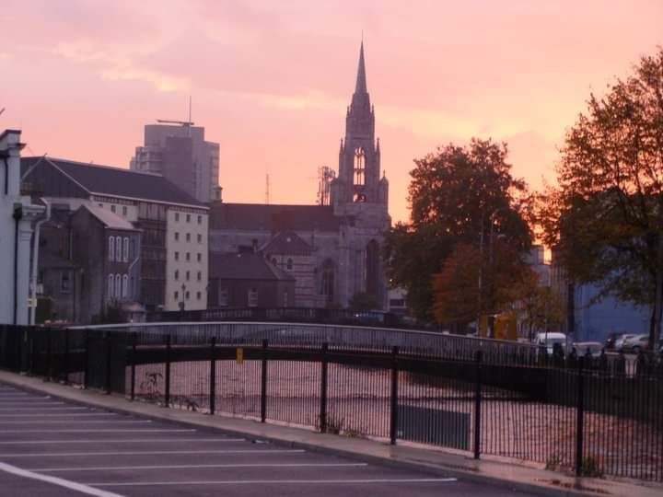  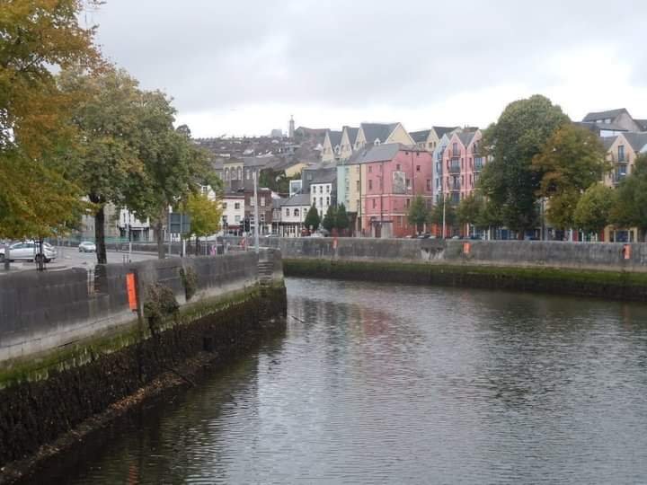 | 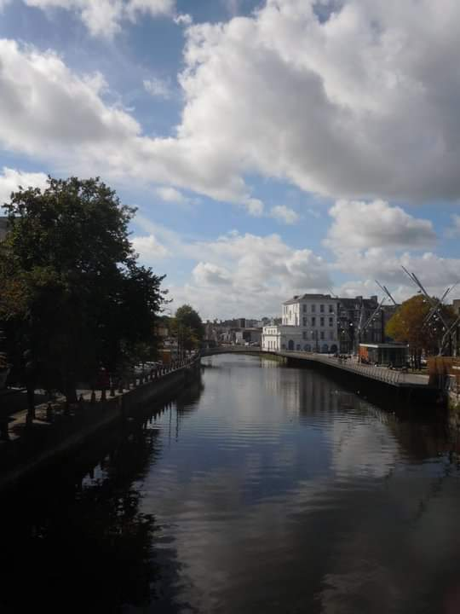

Inside the papers presented in the Annual Meeting of IGU Urban Geography Commission, the Early Career Researcher Committee encourage to researchers send their papers before 15th February.

WEBSITE to access to the whole information on the conference program, registration and forms, accommodation:

Participation is open to all Early Career Researchers participating in the IGU Urban Commission meeting. The prize fund is US$500.

The Early Career Researcher Committee will handle the adjudication process under the supervision of the coordinator. Each paper will be blind reviewed by 2 members of the committee, who will evaluate it by a clear set of criteria. The coordinator will make the choice of the reviewers, will collect the reviews and will make the decision in agreement with the whole committee. The judges’ decision will be final and there will be no correspondence with the authors regarding the decision. The panel reserves the right not to award the prize in any year.

A full paper must be submitted by the author using the abstracts template It shall be 6 pages in length. Only papers submitted in this way will be judged as part of the competition.

Only one text per author may be submitted for the award.

